
Minor Project Report
on
Project Title: -
Course: Database Management Systems-Laboratory
Course Code: CAP280

Submitted by  1.Shreya Kumari  2.Suhani Maurya  3.Lekshmi Nandana U S  4. Yeshwanthi Paypalem | Submitted to  Ms. Komal  Assistant Professor, SCA, LPU

Lovely Faculty of Technology & Sciences
School of Computer Applications
Lovely Professional University
Punjab

Table of Contents
Sr. No. | Content | Page No.
 | Introduction
 | Project Overview
 | Project Objectives
 | Problem Statement
 | ER Diagram and Relational Schema
 | Database Design

SQL Queries and Database Operations

Create Tables

Insert Data

Queries for Data Retrieval
 | Conclusion

1. Introduction

Overview of the Database Management Project

This project focuses on designing and implementing a relational database system for a Food Ordering System, simulating the backend of a real-world online food delivery platform. The system manages various aspects such as customer information, food menu listings, orders placed by customers, detailed order breakdowns, and the delivery status of each order. It is structured using SQL and follows principles of database normalization to ensure data integrity, avoid redundancy, and maintain efficiency.

The database includes five interconnected tables:

Customers

Menu

Orders

OrderDetails

Delivery

Each table is designed with appropriate constraints and relationships (primary and foreign keys), allowing seamless interaction and retrieval of data for practical business use.

Importance of Such Systems in Modern-Day Applications

In today’s fast-paced digital world, food delivery services have become an integral part of urban life. With the growing demand for convenience and time-saving solutions, applications like Zomato, Swiggy, and Uber Eats rely heavily on well-structured and optimized database management systems (DBMS) to run efficiently.

A robust DBMS ensures:

Accurate customer management

Real-time order tracking

Efficient handling of menu items and pricing

Streamlined delivery processes

Data security and consistency

Such systems not only enhance the user experience by providing quick and accurate information but also assist businesses in analyzing customer behavior, optimizing operations, and scaling their services.

This project aims to demonstrate how a basic yet functional food ordering database can be built using core SQL concepts, serving as a strong foundation for more advanced implementations in real-world applications

2. Project Overview

Project Concept and Scope

The Food Ordering System Database is designed to replicate the essential backend structure of an online food ordering and delivery platform. The primary objective of the database is to store, organize, and manage data related to customers, menu items, orders, individual order details, and their delivery status.

This database supports:

Managing customer registrations with contact information.

Displaying a dynamic menu categorized by item type.

Recording customer orders along with date and total amount.

Maintaining an item-wise breakdown for each order.

Tracking the status and date of delivery.

The scope of the project is limited to backend database development without any front-end interface or integration with payment systems. However, the design is scalable and can be expanded to accommodate additional features like discounts, restaurant branches, user authentication, and payment tracking in the future.

What the Database is Supposed to Achieve

The database is intended to:

Ensure data consistency and accuracy across all tables.

Simplify order processing and management for the business.

Enable easy retrieval of customer and order history.

Allow tracking of each order’s item composition and delivery status.

Maintain referential integrity through properly defined relationships and constraints.

By doing so, the system can support the smooth operation of a food delivery service and act as the foundation for both admin and customer-facing interfaces.

Entities, Attributes, and Relationships

The database consists of the following core entities, each with defined attributes and interlinked through relationships:

1. Customers

Attributes: CustomerId (PK), Name, Email, Phone, Address

Description: Stores personal and contact information of customers.

Relationships: One-to-many relationship with Orders.

2. Menu

Attributes: ItemID (PK), ItemName, Category, Price

Description: Stores details of food items available for ordering.

Relationships: One-to-many relationship with OrderDetails.

3. Orders

Attributes: OrderID (PK), CustomerID (FK), OrderDate, TotalAmount

Description: Stores each individual order placed by a customer.

Relationships:

Many-to-one with Customers.

One-to-many with OrderDetails and Delivery.

4. OrderDetails

Attributes: DetailID (PK), OrderID (FK), ItemID (FK), Quantity

Description: Stores detailed item list and quantity for each order.

Relationships:

Many-to-one with Orders.

Many-to-one with Menu.

5. Delivery

Attributes: DeliveryID (PK), OrderID (FK), DeliveryStatus, DeliveryDate

Description: Tracks the current delivery status and date for each order.

Relationships: One-to-one with Orders.

The use of foreign keys with cascading updates/deletes ensures that related data stays synchronized and prevents orphaned records. Together, these entities create a relational structure that reflects the real-world process of placing and fulfilling food orders.

4. Problem Statement

In the modern food service industry, managing customer orders, menu items, and delivery logistics manually or through disorganized systems leads to several challenges, including:

Data redundancy and inconsistency when customer and order details are stored inefficiently.

Lack of real-time tracking of order status and delivery updates.

Difficulty in retrieving historical data for reporting, customer insights, or audits.

Increased chances of human error in order processing, especially when handling multiple orders simultaneously.

Limited scalability of traditional record-keeping methods as the business grows.

Core Problem

The absence of an efficient, centralized database system for handling customer information, order details, menu management, and delivery status results in operational inefficiencies, poor customer experience, and difficulty in scaling food service operations.

Solution

This project aims to solve the above issues by designing a relational database management system that:

Centralizes all critical data in a structured format.

Supports data integrity through primary and foreign key relationships.

Enables easy retrieval of data through optimized queries.

Allows for automatic updates or deletions across related tables using cascading constraints.

Lays the foundation for integration with web or mobile applications for a complete food ordering solution.

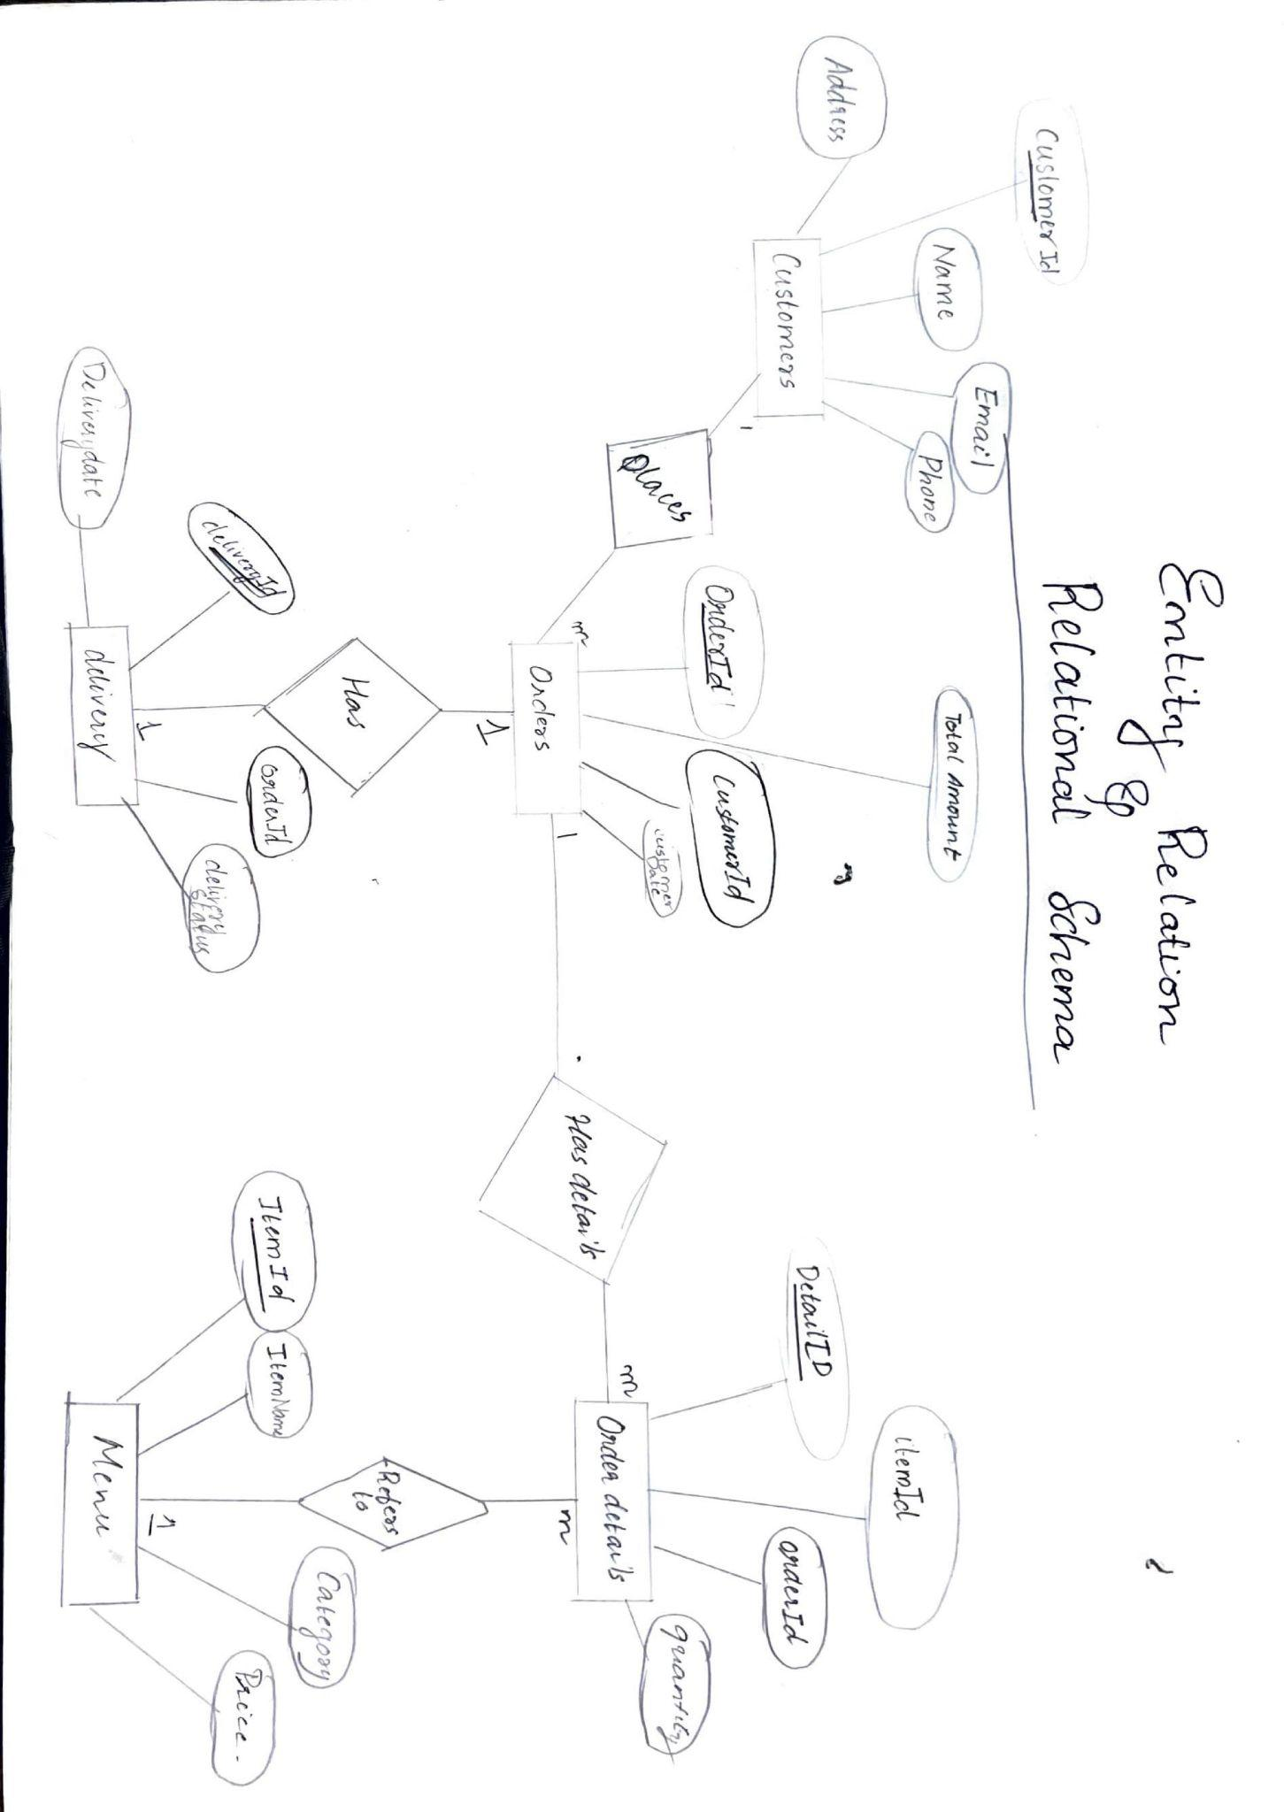
5. ER Diagram and Relational Schema

Explanation of ER Diagram
The Entity-Relationship (ER) Diagram visually represents the key entities of the Food Ordering System and their relationships. It helps in understanding how data elements are connected in the system before converting them into relational tables.

Entities and Their Attributes
- Customer
  - Attributes: CustomerID (PK), Name, Email, Phone, Address
  - Represents the individuals placing orders. Each customer is uniquely identified by CustomerID.
- Menu
  - Attributes: ItemID (PK), ItemName, Category, Price
  - Contains the list of all available food items. Each item is uniquely identified by ItemID.
- Order
  - Attributes: OrderID (PK), CustomerID (FK), OrderDate, TotalAmount
  - Records each order placed by a customer. Each order is linked to a customer via the CustomerID foreign key.
- OrderDetails
  - Attributes: DetailID (PK), OrderID (FK), ItemID (FK), Quantity
  - Acts as a bridge table between Orders and Menu. It contains details of each item in an order, including quantity.
- Delivery
  - Attributes: DeliveryID (PK), OrderID (FK), DeliveryStatus, DeliveryDate
  - Stores the delivery status for each order. It is directly linked to a single Order.

Relationships
- Customer → Orders:
A one-to-many relationship. One customer can place many orders.
- Order → OrderDetails:
A one-to-many relationship. One order can include multiple items.
- Menu → OrderDetails:
A one-to-many relationship. One menu item can appear in many order details.
- Order → Delivery:
A one-to-one relationship. Each order has one delivery status record.

6.Database Design

1. Customers
- Stores customer information.
- Ensures each customer is uniquely identifiable through CustomerID.

2. Menu
- Contains item listings available for ordering.
- Includes a Category field to group similar items.

3. Orders

Captures each order placed, linked to a customer.

TotalAmount helps in billing and analytics.

4. OrderDetails

Represents the itemized details of each order.

Connects each item in the Menu to an Order through foreign keys.

5. Delivery

Tracks delivery status for every order.

A single delivery record is linked to each order.

7. SQL Queries and Database Operations
This section details the SQL queries used to manage the Food Ordering System database. It includes table creation, data insertion, and CRUD operations that support essential business logic like placing orders, updating customer information, deleting entries, and querying reports.

7.1 Create Tables
-- Create Customers Table
CREATE TABLE Customers (
CustomerId INT PRIMARY KEY IDENTITY(1,1),
Name VARCHAR(100) NOT NULL,
Email VARCHAR(100) UNIQUE NOT NULL,
Phone CHAR(10) NOT NULL,
Address VARCHAR(200)
);

-- Create Menu Table
CREATE TABLE Menu (
ItemID INT PRIMARY KEY IDENTITY(101,1),
ItemName VARCHAR(100) NOT NULL,
Category VARCHAR(50) NOT NULL,
Price DECIMAL(10,2) NOT NULL CHECK (Price > 0)
);

-- Create Orders Table
CREATE TABLE Orders (
OrderID INT PRIMARY KEY IDENTITY(1001,1),
CustomerID INT NOT NULL,
OrderDate DATE NOT NULL DEFAULT GETDATE(),
TotalAmount DECIMAL(10,2) CHECK (TotalAmount >= 0),
FOREIGN KEY (CustomerID) REFERENCES Customers(CustomerID)
ON DELETE CASCADE
ON UPDATE CASCADE
);

-- Create OrderDetails Table
CREATE TABLE OrderDetails (
DetailID INT PRIMARY KEY IDENTITY(10001,1),
OrderID INT NOT NULL,
ItemID INT NOT NULL,
Quantity INT NOT NULL CHECK (Quantity > 0),
FOREIGN KEY (OrderID) REFERENCES Orders(OrderID)
ON DELETE CASCADE
ON UPDATE CASCADE,
FOREIGN KEY (ItemID) REFERENCES Menu(ItemID)
ON DELETE CASCADE
ON UPDATE CASCADE
);

-- Create Delivery Table
CREATE TABLE Delivery (
DeliveryID INT PRIMARY KEY IDENTITY(200,1),
OrderID INT NOT NULL,
DeliveryStatus VARCHAR(50) NOT NULL CHECK (DeliveryStatus IN ('Cancelled','Pending', 'Delivered')),
DeliveryDate DATE DEFAULT GETDATE(),
FOREIGN KEY (OrderID) REFERENCES Orders(OrderID)
ON DELETE CASCADE
ON UPDATE CASCADE
);

7.2 Insert Data
-- Insert into Customers
INSERT INTO Customers (Name, Email, Phone, Address) VALUES
('Rahul R', 'rahul@example.com', '9998877665', 'Bangalore'),
('Sneha M', 'sneha@example.com', '8887766554', 'Kochi'),
('Ajay Kumar', 'ajayk@example.com', '7776655443', 'Hyderabad'),
('Karan Rai', 'karanp@example.com','5678956789', 'Delhi'),
('Ankit Bind', 'ankitg@example.com', '2345678789', 'Punjab'),
('Anurag khushwaha', 'anurag@example.com', '4567897896', 'Darbhanga'),
('Rahul Jha', 'rahuljha@example.com', '5678965432', 'Phagwara'),
('Priya Rani', 'priya@example.com', '7654567893', 'Varanasi');

-- Insert into Menu
INSERT INTO Menu (ItemName, Category, Price) VALUES
('Veg Burger', 'Fast Food', 120.00),
('Chicken Pizza', 'Fast Food', 250.00),
('Cold Coffee', 'Beverage', 90.00),
('Paneer Wrap', 'Fast Food', 150.00),
('Noodles', 'Fast Food', 80.00),
('Rice Ball', 'Fast Food', 100.00),
('Ice Cream', 'Dessert', 60.00),
('Brownie', 'Dessert', 100.00);

-- Insert into Orders
INSERT INTO Orders (CustomerID, TotalAmount) VALUES
(1, 220),
(3, 170),
(6, 310),
(2, 300),
(4, 100);

-- Insert into OrderDetails
INSERT INTO OrderDetails (OrderID, ItemID, Quantity) VALUES
(1001, 101, 1),
(1001, 108, 1),
(1002, 103, 1),
(1002, 105, 1),
(1003, 102, 1),
(1003, 107, 1),
(1004, 104, 2),
(1005, 106, 1);

-- Insert into Delivery
INSERT INTO Delivery (OrderID, DeliveryStatus) VALUES
(1001, 'Delivered'),
(1002, 'Cancelled'),
(1003, 'Pending'),
(1004, 'Delivered'),
(1005, 'Delivered');

CURD PROPERTIES
🔹 Create (Insert)
INSERT INTO Customers (Name, Email, Phone, Address)
VALUES ('Neha K', 'nehak@example.com', '9876543212', 'Mumbai');

🔹 Read (Select)
-- Fetch all customer details
SELECT * FROM Customers;

-- Orders with total amount > 200
SELECT * FROM Orders WHERE TotalAmount > 200;

-- Items in 'Dessert' category
SELECT * FROM Menu WHERE Category = 'Dessert';

🔹 Update

-- Update a customer's phone number
UPDATE Customers
SET Phone = '9876543210'
WHERE CustomerID = 1;

🔹 Delete
-- Delete a customer by ID
DELETE FROM Customers
WHERE CustomerID = 5;

8. Conclusion
The Food Ordering System database project successfully demonstrates the design and implementation of a relational database tailored for a real-world food service environment. It achieves the primary goal of efficiently managing customer information, menu items, order transactions, itemized order details, and delivery tracking.
Key achievements include:
- Structured Data Management: Centralized storage for customers, orders, and menu information ensures organized and accessible data.
- Referential Integrity: Proper use of foreign key constraints maintains consistency across related tables (e.g., linking orders with customers and items).
- Efficient Operations: The system supports CRUD operations (Create, Read, Update, Delete), allowing seamless data entry, retrieval, and modifications.
- Real-Time Tracking: Delivery statuses are tracked, enabling businesses to monitor order fulfillment and improve customer service.
- User-Friendly Queries: A variety of SQL queries help retrieve insights like unfulfilled orders, popular items, and customer history.
By meeting the objectives outlined in the project overview and problem statement, this system serves as a foundational model for real-time food ordering platforms used in restaurants and delivery services.

2. Project Overview
Detailed explanation of the project concept, scope, and the core entities involved.
- Define what the database is supposed to achieve (e.g., managing users, subscriptions, and streaming content in the case of a Netflix-like system).
- Briefly explain the entities, attributes, and relationships in the database.

3. Project Objectives
- List the objectives of the project.
  - E.g., Build a structured database to manage content, users, and interactions for an online streaming service.
  - Implement a system that provides users personalized recommendations based on their viewing history.

4. Problem Statement
- Define the core problem the system is solving.
  - Example: "Streaming platforms like Netflix require efficient management of a massive amount of content and user preferences to deliver personalized experiences."

5. ER Diagram and Relational Schema
- ER Diagram: Include the Entity-Relationship Diagram that represents all entities (users, content, subscriptions, etc.) and relationships between them.
- Explanation of ER Diagram: Describe how entities are connected and what attributes are part of each entity.

Relational Schema:
- Provide a relational schema showing the database tables, their columns, and relationships.
- Example for the streaming service project:
  - Users(User_ID, Name, Email, Subscription_Type, Registration_Date)
  - Movies(Movie_ID, Title, Genre, Release_Date, Rating)
  - Subscriptions(Subscription_ID, User_ID, Start_Date, End_Date)
  - ViewingHistory(History_ID, User_ID, Movie_ID, View_Date)

6.Database Design

7.1 Table Descriptions
- Table 1: Users
  - Attributes: User_ID, Name, Email, Subscription_Type, etc.
  - Primary Key: User_ID
  - Description: Stores user information for the platform.
- Table 2: Movies
  - Attributes: Movie_ID, Title, Genre, Release_Date, etc.
  - Primary Key: Movie_ID
  - Description: Contains details of all available content on the platform.
- Other Tables: Describe the purpose and structure of each table.

7. SQL Queries and Database Operations

8.1 Create Tables
Provide SQL scripts for creating all tables.

8.2 Insert Data
Show SQL commands for inserting data into each table.

8.3 Queries for Data Retrieval
Provide queries to demonstrate CRUD operations.
- Example queries to find movies, users with active subscriptions, et
8. Conclusion
Summarize the project achievements and how the system fulfills the objectives defined in the earlier section.

